**Intermolecular Forces, Evaporation, and Vapor Pressure**

3 November 2023

CHEM 1310 Laboratory

*Data and Results*

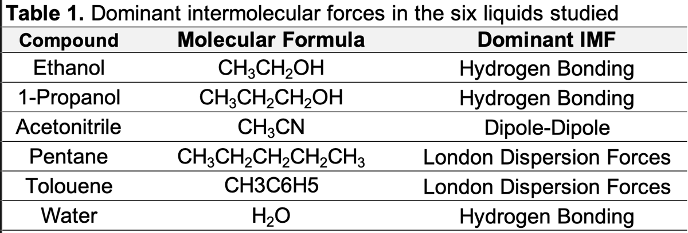

**Table 1.** Dominant intermolecular forces in the six liquids studied.

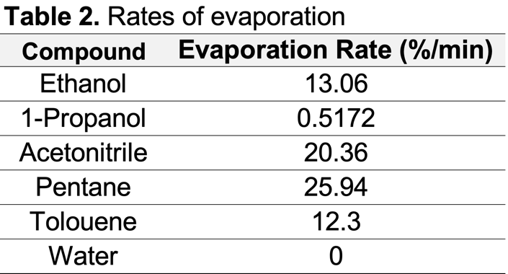

**Table 2.** Rates of evaporation.

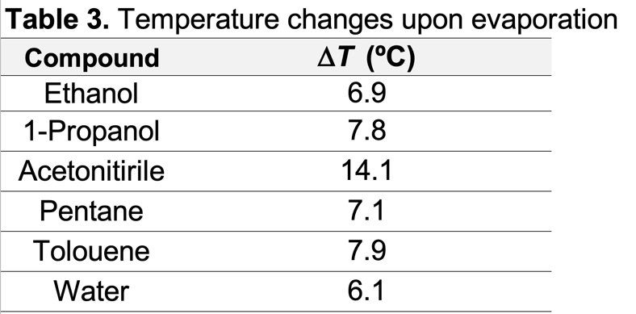

**Table 3.** Temperature changes upon evaporation.

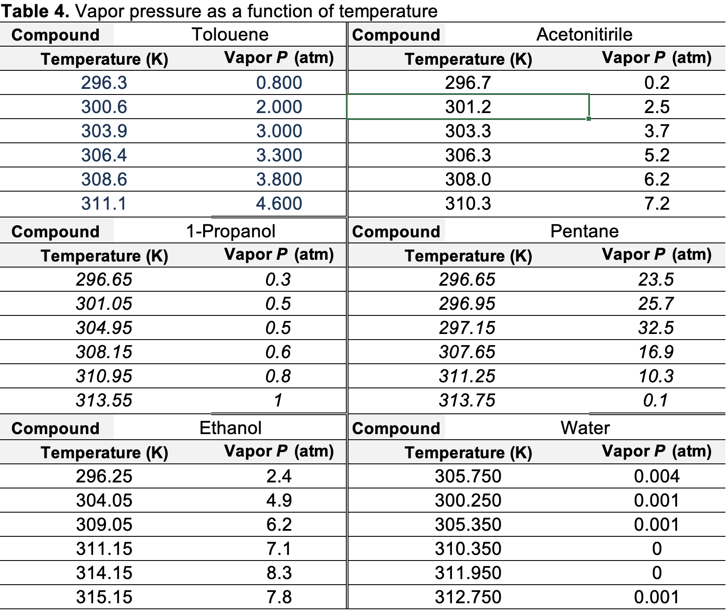

**Table 4.** Vapor pressure as a function of temperature.

*Discussion*

Throughout this experiment observing the intrinsic properties of these liquids, I was able to notice a distinct trend that classifies each liquid based on the strength of its intermolecular forces. In other words, based on the results, there is a direct trend between the measured quantity and the intermolecular forces of these liquids.

The rankings are as follows based on experiment 3 which measured the relationship between time and mass of liquid remaining and experiment 1 which measured the relationship between temperature and vapor pressure. The rankings go from strongest liquid to weakest.

1. Water
2. 1-Propanol
3. Toluene
4. Ethanol
5. Acetonitrile
6. Pentane

Experiment 3 helps us explain the nature of the relationship between evaporation rate and intermolecular force. When we consider on the atomic level of how the molecules interact with one another, we see that as the intermolecular forces increase in strength, the molecule’s bond with one another stronger and there is a decrease in its tendency to evaporate. As such, evaporations rates that are lower indicate stronger intermolecular forces. Additionally, considering the theory behind experiment 1, we can see how vapor pressure maintains a similar relationship to intermolecular force. Vapor pressure is defined as the pressure that the gas exerts on the surface of the liquid it just evaporated from. As a result, if the bonds between the molecules are weaker, there is more entropy within the system and the pressure becomes greater leading to a higher vapor pressure. In other words, there is an inverse relationship between intermolecular force and vapor pressure.

In fact, when we vary the state if the intermolecular force by way of changing the temperature, we see that the trends are maintained for vapor pressure. As the temperature of the liquid increases, on an atomic level, the molecules are bouncing more rapidly producing even weaker bonds between them; this as a result increases the pressure on the surface of the liquid and thus the vapor pressure of the liquid. Table 4 illustrates this because as the temperature of each liquid increases, the vapor pressure does so as well.

Considering all these results and analysis, the boiling points of each liquid can be deduced by following the direct the ranking of the intermolecular forces. From highest to lowest boiling point, here are how the liquids rank with one another:

1. Water
2. 1-Propanol
3. Toluene
4. Ethanol
5. Acetonitrile
6. Pentane

When considering on the atomic interaction level, this makes physical sense since if there exists a high intermolecular force for the molecules, it takes more energy from the surrounding environment to break such bonds and induce a phase change from liquid to gas. Thus, those with weaker intermolecular forces need less energy from their environment to induce phase change and thus the boiling point is lower.